

Retina International

Advocacy Toolkit

Contents

Contents 1
Introduction 3
A Letter from the CEO of Retina International, Ms. Avril Daly 4
Constructing your Advocacy strategy: Where to start? 6
Pick Your Battle 7
Do your research 8
Gathering evidence 8
Regulatory Overview 8
Existing Data 9
Generating evidence 10
Map your stakeholders 11
Some important players to consider: 11
Benefits of Stakeholder mapping: 11
Support vs. Influence matrix: 12
Create a Plan 13
Learn from Others 13
Better Together: Assembling Coalitions 13
Attributes of Effective Coalition Members: 13
Building Consensus 14
SMART Goals 15
Pick your lobbying avenues and tools 16
The Legislative Cycle 16
Examples of Lobbying Avenues & Tools 17
Time for Action 18
Communications 18
Make your communications more engaging: 19
Meeting your representative 20
Before the meeting: 20
During the meeting: 20
After the meeting 20
Monitoring & Evaluation 21
Consistently monitor the state of play 21
Evaluate your own campaign 21
Process KPIs 21
Outcome KPIs: 21
Resources: 22

Introduction

Welcome to the Retina International Advocacy Toolkit.
This comprehensive resource has been designed to provide a framework for creating and implementing advocacy strategies – from picking your particular battle, gathering & generating the information (data) to support it, to deciding on the most effective lobbying avenues available to you.
Retina International strives to enable the community it serves to bring about positive change by thinking globally, and acting locally. Advocacy, or lobbying as it is referred to in some regions, can be daunting and may often seem like a complicated and exclusive process. This toolkit was created to support you, our members, in developing practical, structured advocacy strategies that empower you to be active and involved agents of policy change.
The Retina community is diverse; as are the issues it tackles. As such, the framework described in this toolkit may be applied to many different kinds of advocacy, including research, access to therapies, supports, and more.
We at RI will continually add to this resource to ensure it is up to date and useful for you.
We are, as always, keen to hear your thoughts and suggestions. If you wish to add to this resource, for example, by including an experience from your local community that might benefit your peers, please do contact our colleague Fiona Waters at fiona.waters@retina-international.org

A Letter from the CEO of Retina International, Ms. Avril Daly


We at Retina International are delighted to present this toolkit, designed to support the policy initiatives and advocacy campaigns being undertaken by our global membership, and all stakeholders in the Retina community.
Since being established in 1978, Retina International (RI) has had a focus on driving global policy actions that impact the retina in the area of health and medical research.
Ms. Avril Daly, CEO,
Retina International
We are now entering a new era in health innovation and delivery of care. With the emergence of new therapies for diseases of the Aging Retina and Inherited Retinal Degenerations, this community is understanding the true value of a coordinated and consistent approach to global advocacy in order to amplify our voice and initiate policy actions that will lead to positive change.
Advocacy may be seen as daunting and complex, but through this toolkit we want to demonstrate that it is in fact a straight forward, step-by-step process, that can be employed across many regions and topics. Ultimately, advocacy is a political action, and politics is all about people.
The three steps that guide Retina International’s approach to advocacy is to:
- Listen
- Learn
- Lead
By listening to the needs of patients affected by retinal diseases and those who care for them, and through discussion with health care providers, scientists, and decision makers at the regional, national and global level, we can learn about the gaps in systems, and about the needs of other stakeholders.

We can find a common approach that can help us all to work together in order to lead the change needed to bring better outcomes for patients, through the development of better research infrastructures, care pathways and access to therapies.
The Listen, Learn and Lead approach allows all stakeholders to understand each other’s perspective, to generate the information or data that can support the advocacy argument, and to find workable solutions that are consensus driven and practical.
This approach is one that our Retina community has pioneered for years, and we are now in a pivotal role for influencing the future of healthcare for those living with a retinal degenerative condition. Together, we will work to secure universal access to diagnosis, treatment and care for every person affected by Retinal Degenerative Disease.

Yours sincerely,
Avril Daly
CEO
Retina International

Constructing your Advocacy strategy: Where to start?

When it comes to advocacy, our overarching goal is to move a public health issue specific to our patient community – be it access to genetic testing, therapies, or reimbursement - onto the policy agenda and through the policy-making process. To do this effectively, your organisation will need to develop and implement an advocacy strategy.
A practical framework to creating this strategy is outlined in this document, and can be thought of as a cycle, with the steps as follows:
- Pick your battle
- Do your research
- Map your stakeholders
- Create a plan
- Time to Act
- Monitor & Evaluate
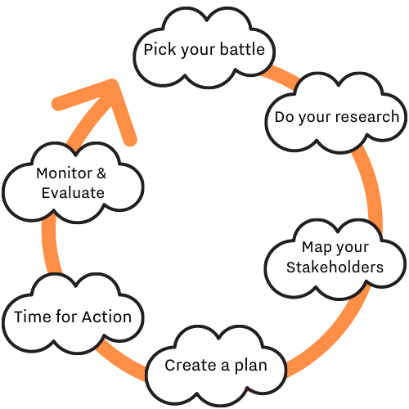
Fig. 1: Constructing your Advocacy Strategy - A Cyclical Approach

Pick Your Battle

Before you start, it is vitally important to be clear on what you are trying to achieve. You can be strategic while also being passionate about your cause.
Some questions to ask:
- Feasibility; Is this an issue that a policy action can address?

- Alignment; How relevant is this issue to the organisation’s mission and purpose?

- Impact; What effect will policy change in this area have on your community?

- Capacity; what skills and resources will be needed to be successful?

Remember to focus your efforts; advocacy is an ongoing task, there are many elements to it and in an effort to try to do everything, it is easy to take on too much. Engage with your community; find out what matters to them, and what can and will make the difference.



Do your research

Gathering evidence

Regulatory Overview
In order to be able to advocate for a change in policy, it is firstly essential to know the current state of play.
A regulatory overview is an analysis of all the existing laws that are relevant to your cause. Depending on where you are from, there may be local, state, federal, national, and/or international laws to consider.
Some useful information to gather about existing laws include:
  - When was the law published?
  - When will the law be changed/amended/revised?
  - Which government department/body is responsible for drafting the law?
  - Who is in charge of that department/body?
  - Which institution can challenge this law once implemented? (ECJ, National Courts, etc.)
This task in itself can be monumental, and sometimes it may be prudent to ask for expert help. There are professional bodies, companies, institutes, and other charities in different disease areas of societal groups who have experience that may be transferable to your particular advocacy issue.
While societal groups and charities are often willing to help, you may be put off asking for help from a for-profit company due to cost. Do not let this put you off as it is possible to ask for pro bono assistance from experts, many corporations and institutions offer assistance and advice as part of their Corporate and Social Responsibility (CSR) programmes. Some have listed the areas of interest on their websites and so it is always worth checking this as a possibility.

Existing Data
In addition to existing policy, make sure that you are up to date on studies and findings that will support your argument. Sources of these may include:
- Experimental research findings – qualitative or quantitative
- Systematic or rapid reviews and meta analyses
- National or international policy or programme evaluations
- Existing statistics – data from patient registries, census data, OECD figures etc.
- Consensus expert opinion
  - Stakeholder consultations
  - Testimonials or case studies
  - Costings of policy options
It is also important to be aware of any data that might conflict with your policy proposal. Be prepared to defend your argument and address these issues.


Generating evidence
In some cases, the evidence you need in order to best argue your case might not even exist. Here, conducting your own research, and generating the necessary data may be a viable and important option.
Here are some tips when setting about conducting your own research:
- Familiarise yourself with the issue as much as possible. Discuss with all stakeholders and develop a clear understanding of the evidence gap.
- Assess and prioritise the value of existing evidence.
- Involve the communities (usually patients) that the outcomes of the research will impact, as soon as is reasonably possible
- If your research project is quite large, consider creating a steering committee, with representation from key stakeholder groups.
- Develop your research question and ensure that the project design will appropriately address your question.
- Identify your research participants, and decide on any inclusion or exclusion criteria.
- Give consideration to all ethical matters arising.
- Identify potential collaborators.
- Prepare a budget and consider funding options.
- Plan for how you will evaluate the success of your research project and its impact on your advocacy.

Map your stakeholders

Stakeholder mapping is the process of identifying the different actors in an ecosystem for a given policy issue, and understanding their level of potential influence and interest in that cause.

Some important players to consider:
Policy & Decision-makers: local, national, international; these individuals should be your main target as they have the direct power to implement policy change.
Allies: other NGOs, learned societies, and experts who are aligned with your cause, and may even be open to coalition. The more groups that support a call to action gives it more chance of success.
Influencers: non-expert parties or individuals who may influence the outcome by direct/indirect or formal/non-formal means; e.g. patient community, scientific journals, industry.
Opponents: those who may resist and oppose the change that you are proposing. Remember that if a party does not appear to agree with your advocacy ask, it does not mean you should not engage. Understanding their perspective is always important and can help shape a better approach.

Benefits of Stakeholder mapping:
- Allows you to identify parties/individuals on whom to focus your campaign efforts.
- Crucial for building coalitions, and elevating your profile(s) as advocates.
- More efficient strategy building, less duplication of effort
- Get creative; is there an avenue here that you haven’t considered before?

Support vs. Influence matrix:
Once you have identified your stakeholders, you can “map” them according to their level of support and influence using the Matrix described below.
For this you can use a 2 dimensional graph, with level of support for change along the horizontal x-axis, and level of influence in creating change along the vertical y-axis. Stakeholders can be placed appropriately in the following quadrants: Supports change and has high influence, supports change and has low level of influence, opposes change and has high level of influence, or opposes change and has low level of influence.
Of these four quadrants, those who support change and have high influence are considered Key Stakeholders – you should manage your relationships with these parties closely, and form alliances where possible. Those who support change but have lower influence should be kept well informed of developments, via newsletters or social media. Those who have high influence but oppose change should be monitored, as their activities may impact yours. Finally, those who oppose change and have low influence may be ignored.
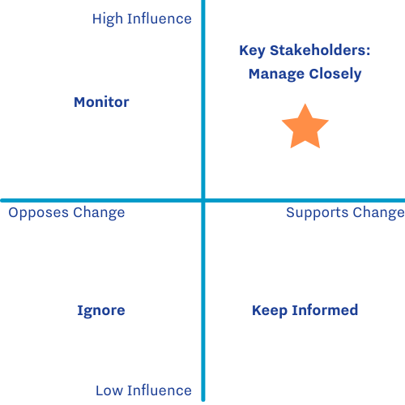
Fig. 2: Stakeholder Mapping - Support vs. Influence Matrix

Create a Plan

Now that you have a regulatory overview, supporting data, and stakeholder map, you are now in a position to design an implementation strategy for your advocacy work.

Learn from Others
We exist in a rich network of charities, non-profits, and NGOs, who are more than often readily eager to share their knowledge and experience with their own advocacy strategy development. Is there a particular campaign that you admire? Why not reach out to the team who developed it and learn from their approach? Understanding what did and didn’t work for others enables your organisation to use your valuable time and resources effectively.

Better Together: Assembling Coalitions
A coalition is a temporary alliance of distinct parties, persons, or states for joint action. Coalitions allow you to broaden your support base, pool your resources and expertise, and leverage your organisational strengths, respectively. While coalitions are crucially important, it is also a big task to build an effective one. When assembling your own coalition, consider some of the following:

Attributes of Effective Coalition Members:
- Willingness and ability to work in a collaborative manner
- Clear understanding of what they can offer (e.g., time, relationships, reputation)
- Clear understanding of what their needs and requirements in the coalition
- Willingness to share resources and power
- Ability to identify creative solutions to problems
- Ability to address conflict constructively
- Sufficient staffing to ensure timely decision-making and task completion

Source: What Makes an Effective Coalition? Evidence-Based Indicators of Success. TCC Group. March 2011.

Building Consensus
Advocacy is a long process. In many cases, you may find that the most time consuming and challenging processes is that of building consensus amongst your stakeholders or coalition partners. Everyone has different ideas and priorities, and trying to meet as many needs as possible is no small feat.
- When engaging in this process, start with a clear and defined introduction of the issue.
- Invite all parties or individuals to express their needs and priorities before discussing a solution.
- Explore all solution options. Weigh up the pros and cons of each suggestion.
- Work together to converge on a proposal that works for everyone.
- Be prepared to compromise, however, have a clear understanding of your own non-negotiables. Present your case, and use the data that you have compiled in your research to support you.
Building consensus helps to create a sense of shared power, develop win-win solutions, and ensure that everyone’s voice and perspective is heard and respected.
An excellent resource for facilitating this process can be found at:https://seedsforchange.org.uk/shortconsensus


SMART Goals
Now that you have consensus on what you are trying to achieve, the next step here is to set some clear goals that will guide you through your strategy. These goals should be SMART goals, where SMART is an acronym for:
  - Specific
  - Measurable
  - Achievable
  - Relevant
  - Time-bound

Specific: A specific goal is one that is clear and unambiguous. We know exactly who is involved and what the purpose is.
Measurable: Decide how you are going to measure your progress or the success of this goal.
Achievable: The goal should be realistic, it should be likely that you will be successful with regard to timeline, capacity, etc.
Relevant: Each goal should advance you towards implementing the change you seek.
Time-bound: Apply deadlines that will keep you on track.


Fig.3: SMART Goals

Pick your lobbying avenues and tools
Now that you have defined your SMART goals, decide exactly how you are going take action.

The Legislative Cycle
Firstly, however, you will need to consider what stage of the legislative cycle the law you are trying to change is currently at, as this will affect your level of influence in policy development. The legislative cycle generally follows the following steps:
- Concept: An agenda or plan for a certain law has been established
- Proposal: A legislative proposal is drafted and developed
- Adoption: The proposal is passed and written into law
- Implementation: The law is then carried out in society
- Evaluation: The law in practice is reviewed
It is important to note that your level of direct influence on policy change is highest in the planning stages, i.e. before the law is drafted.
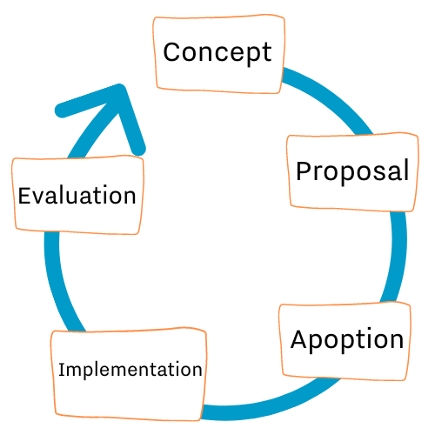
Fig. 4: The Legislative Cycle

Examples of Lobbying Avenues & Tools
There are 4 main kinds of lobbying avenues: Administrative, Legislative, Campaign, and Judicial.

Deciding on the most appropriate lobbying avenue will depend on the stage at which the law is at in the legislative cycle, as discussed in the previous section. It is encouraged to plan to use more than one avenue, as this will increase your chance of success.

The different tools associated with each of these avenues are outlined in the template below:

Cause/Issue: | The problem you are trying to solve
Goal: | What outcome are you looking for at this stage of your advocacy strategy?
Avenue | Tool(s)
Administrative | Ombudsman complaints, Freedom of Information Act requests
Legislative | Influencing legislative outcomes through public consultation fora
Campaign | Petitions, communications, contacting politicians
Judicial | Legal challenge
Table 1: Template for developing your strategy

Time for Action
You are now ready to implement your strategy. In this section, we will focus on two cornerstone aspects that are heavily used during advocacy campaigns: communications, and meeting your representative.

Communications
Communications are becoming an increasingly essential part of advocacy, and spending time on your communications strategy can have a major impact on your campaign success.

When designing your communications strategy, give thought to the following questions:
- Audience: WHO is the target audience?
- Content: WHAT is the most important information to convey?
- Timeline: WHEN does this information need to be shared?
- Context: WHERE will the information be shared?
- Purpose: WHY am I sharing this information?
- Design: HOW can I communicate this information in an interesting and accessible way?

Make your communications more engaging:
Whether it is a speech, a press release, a leaflet, or social media post, you may want to consider the following to ensure your communications engage and captivate your audience:

- Use a variety of communication methods; the more ways your audience engages with your message, the more likely they are to remember it.
- When communicating through written or spoken means, make sure your content is Clear, Persuasive, & Interesting.
- Statistics are powerful, but if you use too many, they lose their impact. Stick to the really important ones.
- Similarly, anecdotes and personal stories can humanise the issue, but must be backed up with solid data and arguments.
- Social and Digital Media are becoming more and more important. Much more than words are needed to communicate with your audience on these platforms. If you are interested in learning about ways to enhance your multimedia engagement/impact, click here to learn more about Mayer’s 9 Principles of Multimedia Learning.
- Most social media platforms (Twitter, Facebook, LinkedIn etc.) and email marketing platforms (Mailchimp) have analytics built in. Familiarise yourself with the different features available, and routinely check to see what is resonating with your audience.

Meeting your representative

Congratulations! You have successfully landed a meeting with your representative. Now what?

Before the meeting:
- Prepare! Decide on the following two things:
  - Key Message – What is the essential information you wish to convey?
  - Key Ask – What can this person do for you?
- It may be helpful to send a brief document in advance, outlining the key facts and figures, to set the stage and establish context for your discussion.
- Put yourself in their shoes. Ask yourself the following questions:
  - Why should they be interested in my issue?
  - What is there to gain from their perspective?
  - Is there something I can offer to them?

During the meeting:
- Give a brief overview of the issue.
- State why you believe this person is well-placed to support you.
- Propose your solution briefly.
- Introduce any coalitions/partnerships you have created.
- Leave the meeting with a pending task; e.g. promise to follow-up via email with a particular document, piece of advice, or contact. This is a good excuse to continue contact after the meeting

After the meeting
- Follow up, multiple times if necessary. Politicians have many demands on their time, so don’t be afraid to put your issue back at the top of their inbox!

Monitoring & Evaluation

Consistently monitor the state of play
Stay up-to-date on developments relevant to your advocacy to identify potential opportunities and challenges.
- Create a Google Alert to check for new relevant documents being published
- Freedom of Information Act requests to access official documents and gain insight into developments.
- Keep an eye on how are new policies are being implemented; are promises being kept?

Evaluate your own campaign
When creating your SMART goals, it is important to consider how you are going to measure your progress, both during and at the end of the campaign. Take some time to integrate Key Performance Indicators into your campaign. Two kinds of KPI’s that may be useful are Process KPI’s and Outcome KPI’s.
Process KPIs: Focus on the means, not the result
Examples:
- How many people / stakeholders you met
- Impact of Communications outputs – Social Media reach, google analytics
- Workflow efficiency
Outcome KPIs: Focus on the ends - the concrete outcome of your campaign
Examples:
- Results: Adoption of a policy goal into a bill
- Behaviour: Increase in political interest/support
- Increased awareness, change of conversation

Resources:

The Good Lobby EU Advocacy Toolkit
Rare 2030: Meeting your MEP
Evidence for Advocacy: A Practical Guide – Health Research Charities Ireland
Advocacy Action Guide: A Toolkit for Strategic Policy Advocacy Campaigns – Bloomberg Advocacy Incubator (BAI) at Campaign for Tobacco-Free Kids
ARVO Advocacy Toolkits
Seeds For Change: Building Consensus
What Makes an Effective Coalition? TCC Group, 2011

The Retina International Advocacy Toolkit is supported through an unrestricted educational grant from Janssen Pharmaceuticals.

